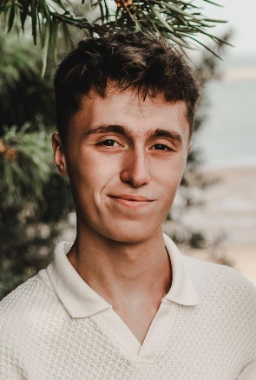
WIlliam Smith
35 Achille Road · 07955 179067
will.smith.work@outlook.com

I am a 6th Form College Student looking for part time work in evenings, weekends and during half term breaks.

Experience

DATES – OCTOBER – SEASONAL WORK

KITCHEN ASSISTANT, GRIMSBY DANCE FESTIVAL
I prepared hot and cold food, drinks and snacks at the beginning of the day. Taking meal orders and serving customers, handling cash and using a credit/debit card machine.
The role involved cleaning tables, sweeping floors, sanitising the kitchen at the end of the shift and restocking shelves and fridges.

Dates From June 2023 – To december 2023

Paper boy, morrisons daily
Getting up early in the morning before school and arriving at the shop to collect my papers ensured my punctuality, and rain or cold weathers proved my determination to complete the tasks given. I delivered papers every weekday and sometimes on a Saturday too. I proved my reliability by providing cover for other newspaper delivery staff when they were on holiday, ill or did not attend work.

Dates From May 2022 – To April 2023

cashier/restocker, cleethorpes rock co.
I would restock shelves and displays, as well as the products available to customers, and would be serving customers at all times. Helping the customers figure out how much everything cost, collecting it all together in a bag and handling money with the register: these all helped with my customer service skills.

Education

2019-2024

GCSE’s, Caistor grammar school
After completing my GCSE’s in 2024, I received the following grades:
Maths – 8
Physics – 7
Chemistry – 6
Biology – 5
English Language – 6
English Literature – 5
History – 4
Computing – 5
PE – 5
French – 5
Further Maths – 5

2024-Current

FRanklin 6th FORM COLLEge
I am now attending Franklin 6th Form College, studying A-Level Maths, Physics & Engineering.

Skills
- Computer literate  - Quick learner  - Natural problem solver  - Trustworthy | - Physically fit  - Good customer service/personable  - Punctual, good timekeeper  - Reliable

Activities
I train at a local basketball club and I volunteer there to coach the younger groups to develop their abilities in the sport. I was learning Spanish from 2019 to 2021, then was learning French from 2022 to 2024 for my GCSE’s, and I will be picking up where I left off with my Spanish knowledge. I also enjoy cycling, both leisurely and to get around to where I need to go.
I am currently providing Maths tutoring to my cousin, following their struggles in gaining a pass mark. I enjoy helping others.

