PROFESSIONAL EXPERIENCE |  | 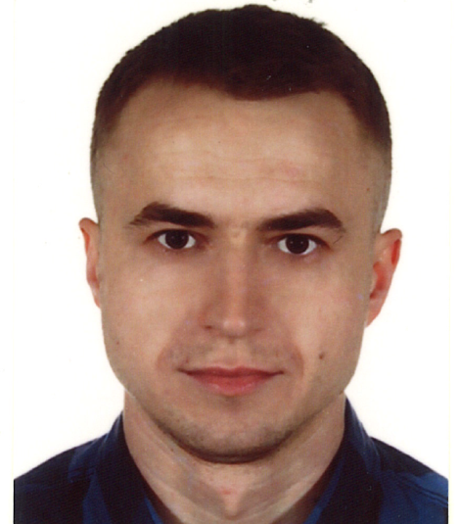  Łukasz Turlej  17 Stanton Square  Peterborough  PE7 8BB Cambridgeshire  Mobile: 0 744 864 54 99  E-mail:  lukasz.turlej.1985@gmail.com  LinkedIn:  linkedin.com/in/łukasz-turlej-40438b119
01.10.21-  ...  03.2019-  08.2021  08.2016-  12.2018  08.2013-08.2016  07.2012- 08.2013  06.2011-07.2012  05.2009-  06.2011  09.2008-12.2008  12.2007-  06.2008 | Class 2, Class 1 HGV Driver for various agencies  SW Group Logistics- Class 2 HGV Driver,  (multi drop delivery driver)  Southern Plant and Tool Hire- Class 2 HGV Driver,  (delivering plant and tools to building sites)  Marine Ventures Ltd. – warehouseman/ handyman,  (managing a small stock room -picking, packing, updating stock, basic plumbing, electric, carpentry, decorating maitenance),  Fawley Court Estate Ltd. – grounds man/ handyman,  (operating a variuos machinery, basic plumbing, electric, carpentry),  Electrician mate at Mont-El, (helping a main electrician with 1. and 2. fix, installation of Low and High Volts equipment),  Online seller of toys at Pebex,  (picking, packing, sending, updating online shop)  Warehouse worker at DHL Poland,  Van driver at Catermed (delivering of chilled food to hospitals).
EDUCATION
10.2009-10.2011  10.2005-02.2009  09.2000-06.2004 | Master of Engineering– Czestochowa University of Technology – Faculty of Mechanical Engineering and Computer Science – Financial IT,  Bachelor of Engineering – Czestochowa University of Technology – Faculty of Electrical Engineering – Technical IT,  High School in Complex High School No. 1 name Stanislaw Staszic in Opoczno, leading subjects: mathematics and informatics.
10.2009-10.2011  10.2005-02.2009  09.2000-06.2004 |  | PROFILE  I am a hard working, honest individual. I am a good timekeeper, always willing to learn new skills. I am friendly, helpful and polite, have a good sense of humour. I am able to work independently in busy environments and also within a team setting. I have strong analytical and problem-solving skills. I love to work manually, using power and hand tools, operating machines, DIY and fixing stuff. I am a typical left-brain thinker.
LANGUAGES
Polish  English | native speaker,  First Certificate in English (FCE).
ADDITIONAL SKILLS
- HGV Class 2 driving licence since 05.2016,
- HGV Class 1 driving licence since 11.2021,
- B category driving licence since 03.2005,
- Forklift licence, Telescopic handler licence,
- CCNA -CISCO Academy course,
- polish electricians association course (SEP 1kV),
- good knowledge of Microsoft: Windows, Office environments.

