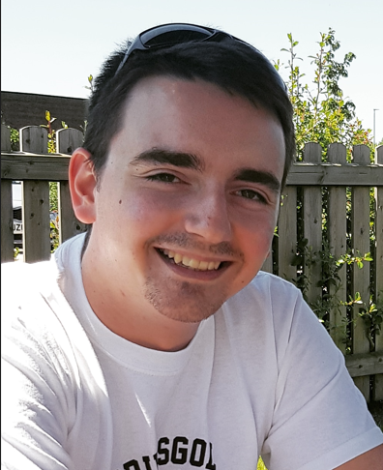
KOBI MATES

EDUCATION

University of Liverpool
October 2022 – December 2022
French Stage 4
Distinction

BPP Birmingham
September 2019 – July 2020
Bar Professional Training Course
Very Competent

Aberystwyth University
September 2016 – June 2019
LLB Criminal Law
2:1

City of Liverpool College
September 2014 – June 2016
Level 3, Extended Diploma, Public Services
Distinction

Southport College
September 2013 – June 2014
Level 2, Forensic Science
Merit

EMPLOYMENT HISTORY

Environmental Waste Management, Vacuum Tanker Driver
September 2023 – Present
I now drive a variety of Class 1 and Class 2 vehicles in the Southeast area, utilising my C+E licence. I am fully trained in the use of vacuum tankers, and am competent driving any type of heavy goods vehicle.

JOD Group, Skip and Roll On/Off Driver
March 2022 – September 2022
Having made a decision to change careers and improve my salary to fund my flying training, I began gaining HGV experience by driving skip lorries and roll on/off lorries for a waste management company in North London.

Joseph Hill & Co Solicitors, Police Station Representative
April 2021 – December 2022
I worked for a firm of criminal defence solicitors in North London, attending police station interviews and preparing cases for both the Magistrates and Crown Courts.

Space Invaders, Delivery Driver
January 2021 – December 2021
I drove a variety of long wheelbase vans, delivering materials to building sites for a company who specialised in loft conversions.

Dominos Pizza, Delivery Driver
March 2020 – January 2021
For the second time in my career, I drove for Dominos, this time in Stourbridge in the West Midlands.

Profile
A confident, motivated, and committed team player, with a wealth of work experience in customer-facing roles.

PERSONAL INFORMATION
D.O.B:
08 June 1997

DRIVING LICENCE
Full UK
Heavy Goods Vehicle, Category C+E

CONTACT
PHONE NUMBER:
+44 7730 327330

EMAIL ADDRESS:
kobi.mates@gmail.com

PERSONAL INTERESTS

My passion outside of work is aviation. I fly regularly as part of my Private Pilot Licence training course, and I hold a full skydiving licence. My dream is to one day fly in the airline transport sector.

I have been studying French for a number of years, as well as living and working in France. As a result, I am competent in speaking and writing the French language.

The Old Cherry Tree, Barman
September 2019 – March 2020
I was a barman at one of my local pubs to help fund studies. My responsibilities were the service of food and drinks, and assisting in the kitchen where needed.

The Royal Pier, Barman
March 2017 – July 2019
During my undergraduate studies in Aberystwyth, I worked at the Royal Pier, which contains a restaurant, pub, snooker club and nightclub. Predominantly I worked in the snooker club section, due to my interest and knowledge of cue sports. My responsibilities were the usual ones of a barman, as well as cleaning the snooker tables.

Dominos Pizza, Delivery Driver
October 2015 – September 2016
I was a delivery driver for Dominos. This involved a lot of mileage and a range of day shifts and night shifts.

Nuffield Health, Lifeguard
June 2014 – August 2015
When I was at college completing my Level 3 Diploma in preparation for university, I worked part-time as a lifeguard, utilising my NPLQ qualification. My responsibilities were to supervise the swimming pool, ensure the safety of all members, and test the chlorine levels of the water using a testing kit.

COMPETITIVE ACHIEVEMENTS

Rosamund Smith Mooting Competition 2020 – Semi Finalist

Welsh University Pool Championship 2018 – Winner

Merseyside Under-25 Snooker Championship 2014 – Finalist

Kirkby Individual Pool Championship 2013 – Winner

UPC Home Nations Pool Championship 2018 – Finalist

REFERENCES

Referee 1 (Personal)
His Honour Judge Robert Altham
07917 867441
robaltham@btinternet.com

Referee 2 (Academic)
Dr Ola Olusanya
01970 622712
ooo@aber.ac.uk

