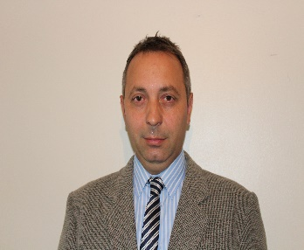 Curriculum Vitae9 Age
First name: CRISTIAN ( middle name Catalin )

Surname: ANGHELUTA

48 age (15 September 1972 )

Address: 11 Selby Court, Kettering, Northants, NN15 5RZ
Home Phone : 07402996004
Mobile Phone: 07449307032
E-mail : cristian_ang72@yahoo.co.uk
silvia_sanremo1978@yahoo.com

Permanent resident in United Kingdom since 2007
Driving Licence valid: 15.12.1994 - 14.09.2042
Driver Card valid: 14.12.2021 - 13.12.2026
Driver Qualification Card: 16.03.2020 - 30.10.2025

CARRER PROFILE :
handy-man skills, hard worker with experience in driving lorry over 9 years around United Kingdom as driver class 1 HGV, LGV, Double Decker, Long Trailer M, Multi Decker MD Argos

OBJECTIVES: looking for a job as soon as possible position job full time permanent as driver HGV class1.

EDUCATION : Mechanic Navy School.

EXPERIENCE:

07 August 2009- December 2011
I worked around as driver on the Car Transporter in United Kingdom, Scotland, Wales for companies 23 Automotive Company, Midas, Gefco, Paragon and recovery lorry and cars;

2012-2021 class 1 driver at Morrison’s Burton Latimer and Eddie Stobart ( present )
I worked for companies as driver class 1 HGV to Morrison’s in Burton Latimer Park Kettering, Argos, DHL
2021-2023 work as class 1 driver for Argos, Co-op, Weetabix, Primark

Hobbies: DJ , school LSA

SHILLS: Professional Full UK Licence category C, C+E
CPC Card valid 2025
Digital Tachograph Card UK
Training for driving attached unit Long Trailer rear steering, Double Decker, Multi Decker, refrigerator trailer box
No points or penalty on driving licence, no accident.

REFERINCE:
Mr. Geoff Smith – General manager Midas Deliveries Company, 23 Automotive
Address: Rockingham Speedway, Corby, NN17 5AF
Tel. (01536) 412186 Mobile: 07590275433

Mr. Andy Mackay- Duty manager Morrison’s Latimer Park
Address: 1 Altendiez Way, Burton Latimer, Kettering, NN15 5YT
E-mail: andymac1509@gmail.com
Tel. 01536421150 ; 07773968490 ; 07891812830 ( contact name Mrs Carrie, Carey)

